Tonight's Cast

Emcees Brandon & Dan
Trixie Amy
Frank N. Furter Diego
Brad Majors Bill
Janet Weiss Sammie
Riff Raff Steffan
Magenta Terry
Columbia Mandi
Dr. Scott Tim
Eddie Wade
Rocky Jason
Crim Leif
Phantom Dan

Transylvanians

Cheryl Poncho Jesus Andrew
Peter Jordan Carlos Kayla

Midnight Mafioso

Stage Director: Brandon Stage Director: Mandi Technical Director: Zac Inventory: Aleah
Tranny Coordinator: Cheryl Webmaster: Bill
Sound: Leif & Tracy Secretary: Aleah
Accountant: Kim Juu Photographers: Liz & Kate
Props Foxes: Jo & Shevaun House Manager: Tracy & Drew
Security: Mark, Jasmine, Fluffy, Data
Merchandise: Jenna, Dakota, Jennica, Tayler
Spotlights: Kim, Lara, Christina, Nikkie, Kate, Jenni, Brittany
Scenic Tech: Zac, E van, Eddie, Siddell

Denton Times
www.midnightinsanity.org
Hey there, all you AWFUL people, and welcome to Midnight Calamity!! First off...APRIL FOOLS!! You're actually here to see Midnight Insanity, and you're not awful...you're gorgeous, beautiful people, and we're so happy you're here for our show tonight!! This week, we take a turn for the strange(r) and (even more) unusual as we celebrate the most wickedly awesome non-holiday holiday around...April Fools' Day! We can't exactly tell you what we're about to do, but trust me, it's going to be hilarious. It's a show like you've never seen, with plenty of hidden surprises in store. So CONDRAGULATIONS, for showing up on such a momentous evening...hope you enjoy!!!

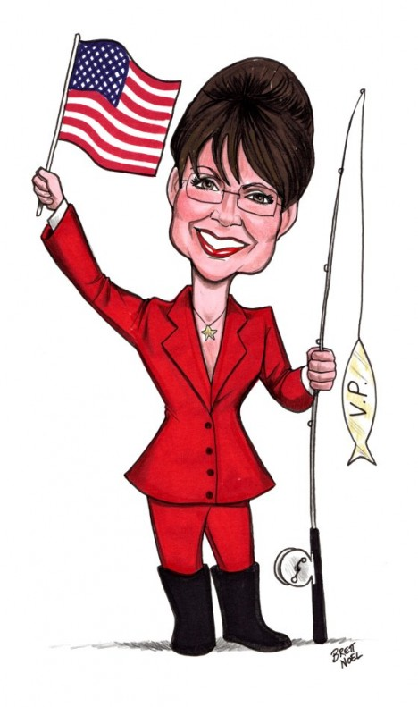
Soo...we had this idea. And it's fantastically AWFUL. In fact, there's only one name for it...HORRIBLE. Be here on April 16th to check out our newest, most outrageous theme night..The Rocky Horrible Picture Show. Come dressed as the most awful, disgusting person you can think of. How many Sarah Palin mama bears will be in the hizzouse? And what about Charlie Sheen and his goddesses? And let's not forget the classics, like Hitler...and Mel Gibson. We'll have a costume contest, prizes, and we're already planning a *very* special Trixie. So make sure you're here on April 16th to participate in the dreckitude.

We've been getting so many requests for our next theme night, we HAD to plan this one a couple of months early. Be sure to clear your calendar for May 14th, because Midnight Insanity will be bringing back 80's Night!! That's right, come celebrate the decade that most of you were born in (or after...*sigh*)by whipping out the hairspray, pulling on the shoulder pads, and breaking out the neon. This is a night you DON'T want to miss.

Like what you see? Want to join the eleganza that IS Midnight Insanity? Well lucky for you, we're always looking for some unsuspecting, innocent fools to corrupt. You don't get paid, but you get invited to our kick ass parties, meet some really awesome people, and you can channel your creativity into something besides that weekly-underwater-basket-weaving-class. So talk to Brandon or Mandi about what you need to do to join our little family...er cult...er cast. Yes, join our happy, harmonious, harmless little cast.

Brandon's Nonsensical Ramblings:
"Good work, Aleah. That's some GREAT penetration."

